XC Vario 6.3
Software Version: 20.0505-10


XC Vario

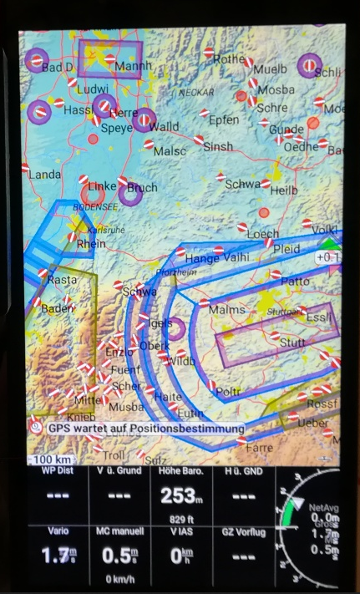
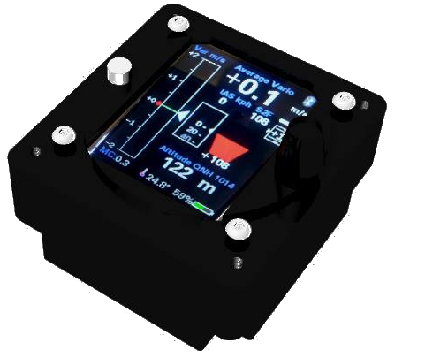


User manual 1.3

info@bluevario.de

Content
1. Preface 4
2. Features 4
3. XC Vario Description 5
4. Usage 5
5. Display 6
5.1. Variometer 6
5.2. Mean Climb 6
5.3. Speed to fly 6
5.4. Altimeter 7
5.5. Recommended Flap setting 7
5.6. Battery display 7
5.7. Temperature 7
5.8. MC-Value 7
5.9. Bluetooth Symbol 7
6. Setup 8
6.1. MC 8
6.2. Audio Volume 8
6.3. QNH Setup 8
6.4. Ballast 8
6.5. Airfield Elevation 8
6.6. Vario 8
6.6.1. Range 9
6.6.2. Damping 9
6.6.3. Mean Climb Minimum 9
6.6.4. Mean Climb Period 9
6.6.5. Polar Sink 9
6.7. Audio 10
6.7.1. Default Volume 10
6.7.2. Tone Style 10
6.7.3. Dual Tone Pitch 10
6.7.4. Audio Mode 10
6.7.5. Auto Speed 10
6.7.6. CenterFreq 10
6.7.7. Range 10
6.7.8. Deadband 11
6.7.9. Octaves 11
6.8. Polar 11
6.9. System 11
6.9.1. Software Update 11
6.9.2. Bluetooth iVario-nnn 12
6.9.3. Factory Voltmeter Adj 12
6.9.4. Factory Reset 12
6.9.5. Battery Limits 12
6.9.6. Display Orientation 12
6.9.7. Altimeter Source 12
6.9.8. Units 12
6.9.9. Rotary Default 13
7. RS232 Serial Interface 13
7.1. Serial RS232 Speed 13
7.1.1. Serial BT Bridge 13
8. XC Soar 13
8.1. XC Soar Configuration 14
9. Installation 14
9.1. Drill Pattern 15
9.2. Audio Out 15
9.3. RJ45 socket 15
9.4. Pin-out 15
9.4.1. Patchkabel connection 16
9.4.2. Temperatursensor 16
9.4.3. Power supply 16
9.4.4. Speed to fly (S2F) switch 17
9.4.5. RS232 port 17
9.4.6. RS232 BT Bridge 17
10. Technical specifications 18
11. Maintenance 19
12. Warranty 19
13. Limitation of liability 19

Preface
The XC Vario is a modern variometer system with a vario display, speed and nominal travel, altimeter and optional flap recommendation. There is also a temperature and battery status display, as well as a data interface to the free software XC-Soar. The device is an excellent replacement for old variometers with additional modern features.
The hardware is based on three modern semiconductor pressure sensors, with outstanding properties such as accuracy and long-term stability. They are energy-saving and fully calibrated at the factory, have a resolution that has never been seen before and can therefore already recognize pressure differences with a height difference of only 8 cm.
A digital temperature sensor provides additional information about the outside temperature and is an important component for the calculations in the atmospheric model of XC Soar. The Vario is compensated for by the pressure of the TE nozzle and offers an audio function via the built-in loudspeaker.

Features
- TE-Variometer with optimized Kalman Filter, adjustable range und Damping
- Barometric Altimeter mit QNH adjustment or QNH Autosetup
- Indicated airspeed and speed to fly
- Adjustable wingload (ballast) and MC Cready vallue
- Build in Loudspeake with volumecontrol
- Tone Style individuell konfigurierbar
- Optional Flap recommendation box
- Polar library with more than 80 common polars
- User-Polar user defined polar
- Outside air temperature display with external sensor
- Battery state of charge display
- Bluetooth Interface or a serial RS232 port for XC Soar
- Barometric altimeter with high accuracy
- Sunlight readable, bright 2.4 inch IPS Display
- Switch input for vario / S2F
- Easy Setup Menu by Rotary Encoder with push function
- Light and small device for standard 57mm Instrument cutouts
- Robust and shielded CNC machined flat black anodized aluminium case
- Software Update over Wifi ‘Over The Air’ (OTA)

XC Vario Description
The XC Vario is constructed with the most modern and high-resolution barometric sensors, this means that no expansion tanks are required. The resolution of these sensors is 0.01 hPa, which corresponds to an approx. 8 cm difference in height.

The sensor for the dynamic pressure, speed or IAS enables an absolute accuracy of better than 1%, at 100 km / h the deviation is a maximum of 1 km / h. The digital temperature sensor has an absolute accuracy of 0.5 ° C. All components are long-term stable and very reliable.

The data transfer to XC Soar can either take place via Bluetooth or alternatively via an RS232 (TTL) interface, depending on which interface the device uses. Bluetooth has the advantage that there is no hardware connection with a cable.

The outside air temperature is measured by a precise digital temperature sensor in the ventilation area in order to be taken into account when calculating atmospheric parameters such as the air density in XC Soar, and thus to be able to run more precise values for speed to fly and climbing.

It is operated via a rotaryswitch with a push button and there is a push button for power ON / OFF.

Usage
After switching on on the ground, the QNH must first be set using the rotary knob. After pressing the rotary button, the device goes into operation.
Turning to the left will decrease the volume, increasing accordingly when turning to the right.
In operation, the menu for parameters such as MC value, ballast, polar and more is started after pushing a button.
A simple push takes you to the top point of the setup [<< Setup], which offers a return from the setup without turning, i.e. scrolling in the menu. Another push without scrolling alternates between setup and normal operation.
By turning clockwise according to Scroll Down or turning left for Scroll Up, the individual sub-items are selected in the setup.
Most of the items in the setup menu return to the top item of the previous level, so that several settings can be made without leaving the menu entirely.
The setup menu is nested, the individual items can be pushed down further, the top item returns to the previous menu.
All values that can be adjusted are reduced by turning to the left and increased by turning to the right. If you want to save the value, you can acknowledge this with push, the saving is confirmed and returned from the dialog.
Dialogs for parameters that are usually set separately, such as the MC value, return directly to the vario display. This saves another push of a button.

Display
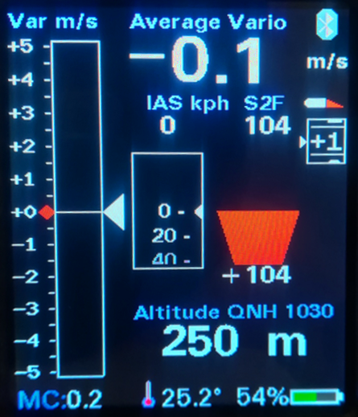
The display consists of several components for vario, speed, speed to fly and altitude. In addition, the MC value, the outside temperature, the battery voltage, the status of the Bluetooth connection and optionally recommended flap settings are displayed.

Variometer
On the left is the most important display, the variometer. Climb values are shown with a green bar at the top and a red bar at the bottom.
The white arrow moves with the climb value.
The value averaged over 5 seconds is displayed digitally to the right of it.
By default, the polar self sink is shown in the variometer display as a blue bar downwards depending on the speed. In completely calm air, a blue bar is shown from 50 km / h Pitot pressure, which corresponds to the polar self sink (SS) at the current speed and load. If it also falls, the red bar below the blue bar extends the display to the current sink value. When climbing, the blue bar is overwritten with a green bar according to the rising air mass from below. The length of the red or green bar corresponds to the net variometer value, at the end of the bar you can see the gross variometer value, the actual rise / fall from the bottom. The various variometer displays are shown in the following sketches. Activated on the left with the option for polar subsidence, on the right the classic display without displaying the polar self sink, i.e. without information about the net climb values.
Calm Air , Only SS Climb < SS Sink Climb = SS Climb > SS

0
0
0
0
0
-1
-1
-1
-1
-1

Mean Climb
The avg climb is shown as a small red dot to the left of the variometer scale and moves upwards accordingly. Climbing values that are too low, which you do not want to include in core climbing, can be hidden in the Vario dialog.

Speed to fly
The speed indicator is in the middle of the display. This small box shows the current speed in the form of a moving scale, the small white arrow in the middle of the box points to the current speed value. Above this box is a digital display of the current IAS value. Next to it on the right is the exact value of the target speed (S2F Speed2Fly), also digital.
Below the S2F value, the actual speed to fly indication is in the usual way. A red arrow for pushing your stick to fly faster , and for pulling up in green to fly slower. The length of the arrow is measured with the difference in the IAS and S2F, the tip of the arrow is cut off from a difference of about 45 km / h, the arrow becomes wider with increasing deviation.
If there is a deviation of more than 10 km / h, the exact value of the deviation is displayed below or above the command arrow.

Altimeter
The current altitude and the associated QNH value are displayed below the speed to fly field.

Recommended Flap setting
On the right edge below the small wing/flap section is the flap display, which gives a recommended Flap setting for your aircraft. Five different positions can be shown in the form of a moving scale: -2, -1, 0, +1, +2. The small profile moves the flap shown in red in the same way as the recommendation. The associated optimal speeds corresponding to the polar can be adjusted in the setup depending on the model. The flap display must be activated in the setup under / Flap (WK) Indicator / Flap Indicator Option / [Enable].

Battery display
The battery display shows the state of charge of the battery in the form of a symbol in different colors. The exact value in percentage is also displayed. When the battery is running low, the color changes from green to yellow, then red. The symbol also flashes red. The corresponding voltages are preset for a lead acid battery and can be modified in the setup.

Temperature
The temperature at the bottom of the display shows the value of the outside temperature in ° C. If there is no sensor or the sensor is defective, the value shows "---".

MC-Value
The MC value shows the currently set MC value. The MC value is the top value in the setup menu and can be easily modified by selecting it and pressing the button..

Bluetooth Symbol
The bluetooth symbol shows with blue color an existing connection to the XC Soar device and the exchange of data. If there is no connection or no more data is exchanged, the symbol is shown in gray.

Setup
Many parameters can be set in detail in the setup menu. The most important parameters are in the main menu

MC
The MC value can be set in 0.1 m/s steps from 0 to 9.9 m / s. After confirmation by pushing the rotary switch, the Vario returns back to normal operation.

Audio Volume
Volume control. If the volume is set in Setup / System / Rotary Default / [MC Value] instead of [Volume], the volume is set here from 0..100%. This setting makes sense if the external audio e.g. the audio input of the radio is used, so that its volume control can be used.

QNH Setup
Dialog for setting the QNH value. On the ground, set the value so that the altimeter display, also shown, shows the airfield elevation (Airfield Elevation), or to the QNH value of the closest ATC.

Ballast
In the Ballast Dialog, the wing loading can be adjusted upwards to take water ballast or an additional person into account in the two-seater. The surface load for which the polar was flown and recorded is shown at 0% ballast.
Example: A glider with a wing area of 10m2 has a set-up weight of 260kg, the pilot weighs 80kg, 100 liters of water (100kg) are tanked. The take-off weight is therefore 440kg, corresponding to the wing load 440kg / 10m2 = 44 kg / m2. The polar was flown at 34.4 kg / m2 without water.
The setting of the ballast can now be increased in percentage steps or even more easily according to the surface load also shown, i.e. to 28% corresponding to approx. 44 kg / m2.
After draining the water, the ballast must be turned back to 0%.

Airfield Elevation
If the value for the airfield elevation is recorded here, the QNH is automatically adjusted to the given airfield elevation after switching on. This can only be confirmed in the QNH dialog. If you land on a different place with different heights, you have to adjust the setting manually to its field elevation or use the QNH of the closest ATC.

Vario
The settings for the vario display can be adjusted in the vario dialog.

Range
The range of the variometer is set with a range from 1 m / s to 30 m / s can be selected for the min / max values. The default setting is 5 m / s,

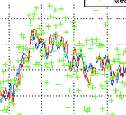
Damping
Damping regulates the time constant for smoothing the variometer display. Normal thermal is inherently turbulent, which means that an undamped Vario display provides the pilot with hardly any information that can be evaluated. Time constants of a few seconds are common. Excessive damping delays the display with simple low-pass filters. The optimized Kalman filtering, which takes physical conditions into account and thinks ahead, reacts quickly without being nervous. The default is 3 seconds. Values ​​up to 6 seconds can be useful for an even smoother display.

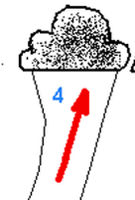
Mean Climb Minimum
For the calculation of the mean climb, low climb values, which are available for example in straight flight at high speed, can be hidden. According to a modern recommendation, only the core climbing when circling should be used for the MC value, not the climbing values in straight flight or when centering. This value is taken into account in the calculation that defines the mean climb minimum . The default is 0.5 m / s.

Mean Climb Period
Following a recommendation, the climb values of the last 3 thermals should be taken into account as the average climb for the MC value. From the analysis of many flights you can see that a new thermal area is approached every 15 minutes. With a default setting of 45 minutes this is taken into account, so only values from the last 45 minutes are taken into account. The value can be changed in steps of minutes.

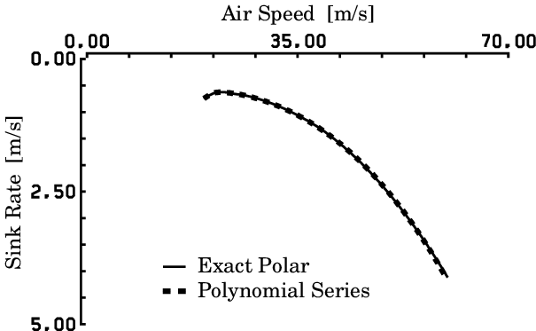
Polar Sink
By selecting [ENABLE] (default setting), the polar sink rate is shown in the variometer display depending on the speed. This setting can be changed with [DISABLE], the polar sinking is then no longer displayed.

Audio
The tone generator is an important part of improving safety in the cockpit, as it allows keep attention to other aircraft. The tone changes with the rate of climb in pitch in intervals between 100 mS long pauses (or a second tone), and is emitted via the internal loudspeaker on the rear of the housing.


Default Volume
In this setting, the volume that is set after switching on the device is configured. The default is 40% volume.

Tone Style
This setting selects whether a simple tone with short interruptions is desired (di di di di) or whether the Vario works in two-tone mode [Dual Tone] (di da di da). The two-tone mode is preset.

Dual Tone Pitch
This setting is only relevant in two-tone mode. It gives the pitch, i.e. the pitch change of the second tone. The second tone is offset by this percentage in pitch. The default is 12%.

Audio Mode
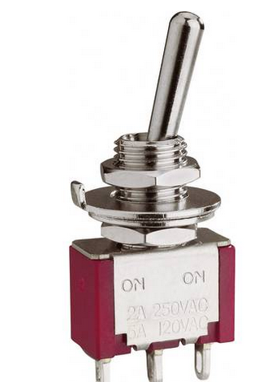
The audio mode indicates to what extent the tone generator follows the variometer or the speed to fly switch. There are four options. The tone generator can either be set permanently to Vario [Vario] or speed to fly [S2F]. Then there is the option via the external switch, e.g. a stick switch or switch in the panel to switch the Vario / Desired mode [Switch]. If the changeover is to take place automatically from a certain speed, select [AutoSpeed] (default setting).

Auto Speed
This is the speed at which the tone generator changes from the variometer to S2F. The default is 100 km / h. With higher wing loads and modern gliders, the value can be set higher.

CenterFreq
Specifies the center frequency of the tone generator and can be modified in 10 Hz steps. The default is 500 Hz.

Range
This determines whether the tone generator follows a fixed range setting [Max eq. 5 m / s], or the current variometer range setting follows [variable (X m / s)]. The range defines from which value the tone generator outputs the highest or lowest frequency and interval sequence. It can make sense to assign the area dynamically in the case of weak climbing. With dynamic setting and a range of 2 m / S of the Vario, 2 m / S sound the same as otherwise 5 m / s with a fixed setting. The default is [Max e.q. 5 m / s].
5 m/s or Variable ?

Deadband
The deadband indicates the area where the Vario does not make any sound. There is the [Lower Val] for the negative value and the [Upper Val] for the positive values. The default is + -0.3 m / s for the deadband. The deadband helps to hide small climb values ​​and to keep calm on the ground without having to adjust the volume.

Octaves
This determines how many octaves the tone change extends between the zero value and the lowest, as well as the zero value and the highest tone. The value can be changed in 0.1 steps between 1.5 times and 4.1 times. The default is 2 times. A value that is too high produces tones outside the optimal spectrum for the loudspeaker and human hearing.

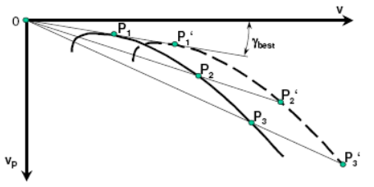
Polar
In the Polar dialog you can choose the aircraft type and adjust the polar manually. There is a polar [user polar] that can be maintained independently of the polar from the library, e.g. for an aircraft type that is not in the library. Under [PolarAdjust] the wing loading [Wingload], and the corresponding speed [Speed 1,2,3] and sink values [Sink 1,2,3] can be modified at three points.

System
In the system menu various things related to the hardware and software are managed.


Software Update
The software of the device is freely accessible as open source on github page: https://github.com/iltis42/OpenIVario
Software releases are published on: https://github.com/iltis42/OpenIVario/tree/master/images , and can be imported OTA (Over The Air) via a Wifi Access Point of the Vario’s. First save the new firmware, e.g. the file sensor-20.0505-10.bin locally on an Android device (mobile phone).
Then start the update in the Vario Setup under System / Software Update / [Start Wifi AP] and change to the WiFi “ESP32 OTA” according to the dialog. Once this has been done, the new firmware can be selected on the website http://192.168.0.1 and uploaded. The dialog guides you through the download with progress indicator and shows the success both on the website and on the variometer.
If the software download was selected on the Vario, but no file was selected and loaded, there is an automatic timeout after 15 minutes and the old software restarts. In this case, wait for the timeout.

Bluetooth iVario-nnn
The dialog is used to activate [transmitter ON] and deactivate [transmitter OFF] the Bluetooth interface. The name of the Bluetooth connection is also displayed. The identifier: iVario-nnn refers to the software coming from OpenIVario plus the three-digit serial number of the device. The default is [Sender ON]

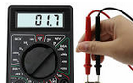
Factory Voltmeter Adj
Optional dialog which can only be used in the factory for precise fine adjustment of the battery voltage measurement in order to achieve maximum accuracy. If the adjustment has already been made, the dialog is suppressed. After a factory reset, the dialog appears and enables precise adjustment. Without this setting, the measurement is accurate to approx. 1%. To do this, a multimeter is required to measure the voltage exactly.

Factory Reset
Allows a reset to all device settings as came from the factory.

Battery Limits
Setting the voltages for battery low (0%), red (10%), yellow (20%) and full (100%). The voltages are preset for a lead acid battery.

Display Orientation
The display orientation can be inverted, so that the rotary knob moves to the other side. [NORMAL, Rotary left] and [TOPDOWN, Rotary right] are available.

Altimeter Source
Either the [TE Sensor] or the [Baro Sensor] can be selected as the source for the altimeter. The Baro Sensor is preset. The TE sensor only makes sense if you want to have the energy level displayed, or for test purposes.

Units
For international use, the units can be set as desired, the setting options are as follows, the default setting is printed in bold:
Altimeter [Altimeter]: Meter (m), Foot (ft) or Flightlevel (FL)
IAS [Indicated Airspeed]: Km per hour (km / h), Miles per hour (mph) or Knots (kt)
Vario [Vario]: Meters / sec (m / s), Feet per min (ft / min) or Knots (knots)

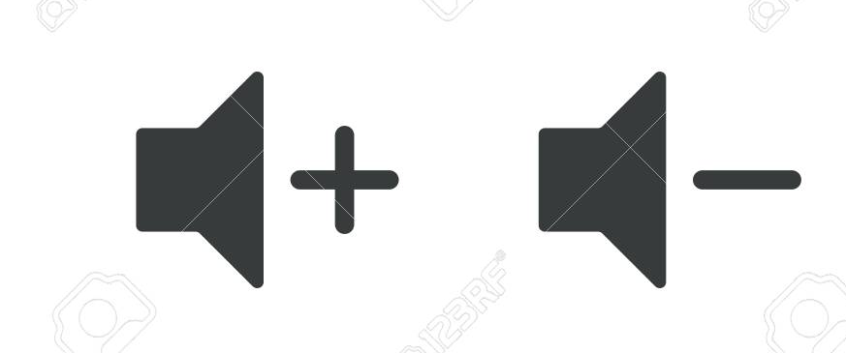
Rotary Default
or MC Value
Via the (pre) setting for the rotary switch (Rotary Default), it is determined which setting is changed in the vario mode by turning the rotary. You can choose between [Volume] for the volume and [MC Value] for the MC value. The default is [Volume]. If you don't need the volume control, e.g. When using an external audio device with its own volume control, or if changing the volume using the setup is sufficient, the MC value can also be used here.

RS232 Serial Interface

Serial RS232 Speed
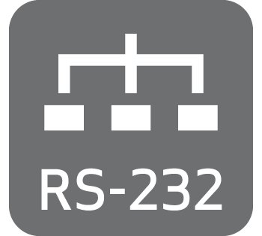

The RS232 interface is used to output the serial OpenVario data (TX) aswell as a Serial to Bluetooth Bridge (RX) around another serial device, e.g. connect a Flarm to the device running on the XC Soar. Under the option [Serial RS232 Speed] the speed between 4800 and 115200 baud can be set in the usual baud rates, or switched off [Serial OFF]. The interface is switched off by default. The speed setting always applies to both directions RX and TX.

Serial BT Bridge

….

The Option [Serial BT Bridge] activates a Bridge Funktion [Enable] or switches it of [Disable]. The data of a serial device connected to the RJ45 connector pin 2 e.g. a FLARM are buffered each time a line breaks (\n) and sendet via Bluetooth to XC Soar. The default setting of the bridge is switched off.

XC Soar
XC Soar is a OpenSource Software and runs on many Android devices. These usually already include a GPS receiver which provides sufficiently accurate GPS data for the current position or the speed over ground.
For a complete glider calculator however, other values such as dynamic pressure, TE Probe pressure, static pressure are missing in order to be able to run a useful vario display or information for the flight on your the current XC flight . The XC Variometer delivers exactly this data to XC Soar either via Bluetooth or a serial RS232 interface.

The XC Soar software can run on many hardware platforms, including Android devices such as modern smartphones or Android sat navs with a bright color display and 7 inch screen.
These are now available on the market with sufficiently bright displays and touchscreens, and are well suited for use in the cockpit. With the XC Vario, this technology is available at an affordable price.
In flight mode, the vario display in XC Soar can also provide precise target S2F information. Together with the XC Vario, XC Soar offers a state-of-the-art glider calculator with intuitive touchscreen operation, many screens full of features for thermal cranks, pre-flight, final approach with freely configurable info boxes, representation of terrain with airspace including side view. Displays with topography and landing fields, assistants for competitions, vario with acoustic function, S2F sensor for MC or dolphin flight and much more.

XC Soar Configuration
On the device with XC Soar, e.g. Tablet or smartphone, the XC Vario can be integrated into XC Soar with just a few clicks. To do this, Bluetooth must be activated and the Vario must first be paired as a Bluetooth device in Android.
To do this, perform a device scan in the Android device under Bluetooth, and pair the Vario, which should appear as "iVario- [nnn]" in the pairing dialog. The three-digit number is the serial number of the device.
If a Bluetooth password is requested, it must be specified with "1234".
Then in XC Soar under Config → NMEA connection, select a previously free (deactivated) connection A..F for 'editing'. The Vario should then e.g. appear as 'iVario-123'. Select this and enter 'OpenVario' in the following dialog, the K6Bt switch remains on 'Off'. After acknowledging the dialog with “OK”, XC Soar will connect to the Vario within a few seconds, which will then function as a regular NMEA connection with the status “Connected; Baro, Vario ”is displayed.
Under 'Monitor' you should now see the Vario’s $ POV NMEA-Sentences, with sections for the individual pressures, temperature or voltage. The protocol is at: http://www.openvario.org/doku.php?id=projects:series_00:software:nmea dokumentiert.

OpenVario Data example:
$POV,P,978.1,Q,0.0,E,-0.0,T,15.0*4F
$POV,P,978.1,Q,0.0,E,-0.1,T,15.0*4F
$POV,P,978.0,Q,0.0,E,0.5,T,15.0*47
$POV,P,978.0,Q,0.0,E,1.0,T,15.0*47
$POV,P,977.9,Q,0.0,E,1.3,T,15.0*42
P: Barometric Pressure (hPa), Q: Pitot Presure (Pa), E: TE-Vario (m/s), T: Temperatur (°C)

Installation
The XC Vario was kept simple in terms of installation and configuration.
Installation in the cockpit is very easy. The pressures required for the XC Vario can be connected to the instrument hoses of the mechanical instruments using 6 mm T or Y connectors . If these connections are not already available from a previous Vario, the instrument hose can be cut at a suitable point and the connection for the Vario can be made using a T-Connector.

Es werden benötigt:
- Static pressure port marked ST
- Pitot tube pressure marked PI
- TE-probe pressure marker TE

The electrical connections are made via the RJ45 socket and optionally the audio socket on the rear of the device.

Drill Pattern
The instrument corresponds mechanically to the aviation standard for instruments with a diameter of 57mm. The holes for four M4 instrument screws should be at least 4.5 mm.

m
mm
4.5 mm
66 mm
45°

57 mm Durchmesser

m
mm

Audio Out
A 3.5mm jack provides an external output for the audio signal from the variometer. Either an own external loudspeaker can be connected to it, or an audio input of a radio can be used. The internal loudspeaker of the variometer is usually sufficient, but it can make sense e.g. to be able to hear the signal when operating with headsets, or to connect an external loudspeaker closer to the head in noisy cockpits. The internal loudspeaker switches off if an external audio device is inserted.

RJ45 socket
On the back is the RJ45 socket, which is intended for an 8-pin LAN patch cable. Power supply, RS232 interface, temperature sensor and the switch for the vario/S2F are connected via these pins/wires .
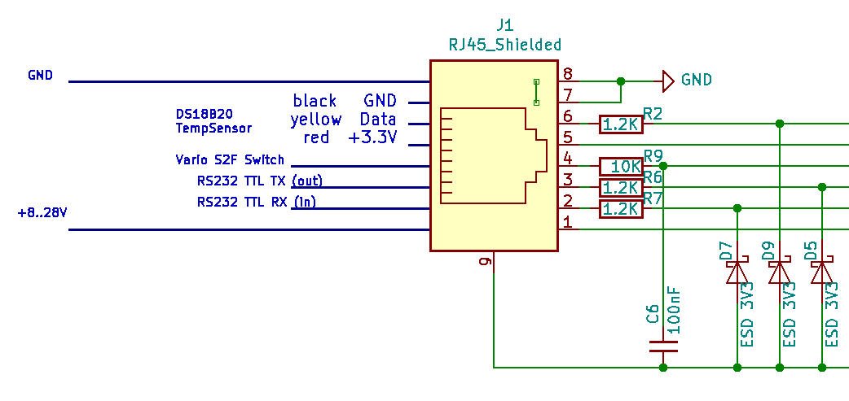

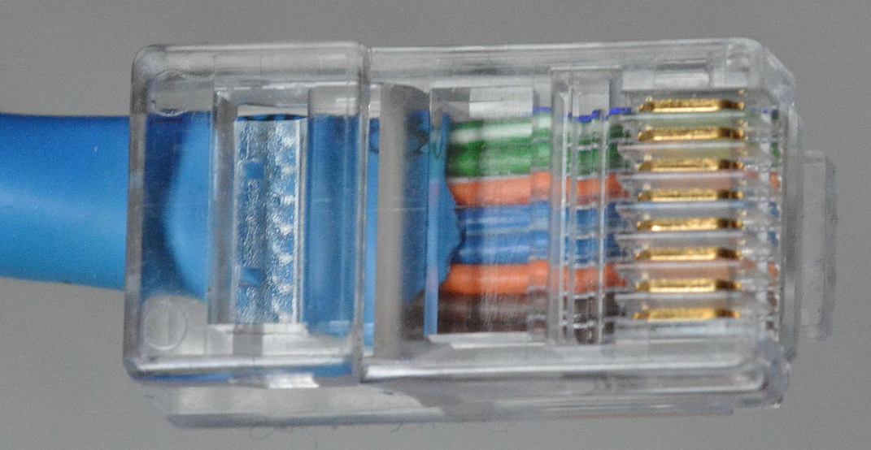

Pin-out
- Plus +8..28V (Power Input)
- RS232 TTL RX (Input)
- RS232 TTL TX (Output)
- Vario/S2F Switch (Input) Open: Vario, GND: S2F
- Temp-Sensor Pluspol 3.3V (Output) Red
- Temp-Sensor Data (Input) Yellow
- Temp-Sensor GND (Output) Black
- Minus GND (Power Input) Temperatursensor

Patchkabel connection
You can assemble your own RJ45 connector with suitable cables, or use a standard LAN patch cable with the following color coding. There are European (568A) and American (568B) standards, with differences in color coding. Measure in doubt. With a 568A cable, white / green line, pin 1 would be the positive pole supply and brown with a white line (or brown), pin 8 would be the negative pole.
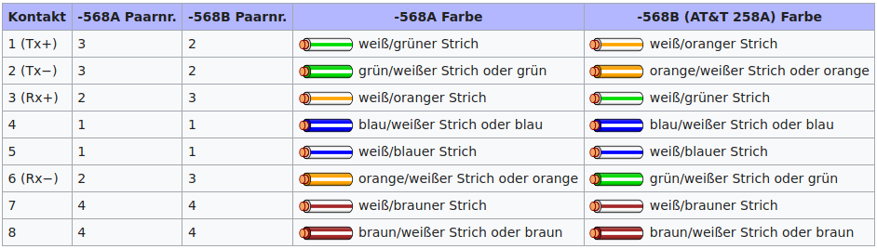

Temperatursensor
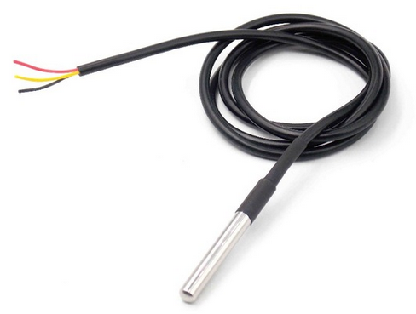
The temperature sensor is a ready-made Dallas DS1820B sensor with a waterproof jacket and a 1.5 meter long cable. These sensors have three colored lines, which are usually coded with the colors red, yellow and black. If a separate sensor is used, the manufacturer's instructions must be observed.
In order to measure the outside air temperature,the sensor is inserted in the front ventilation.
This can also be done in the ventilation pipe if available. In this case, cut a small slot with a cutter knife, insert the temperature sensor and e.g. sealed with aluminum adhesive tape or silicone.

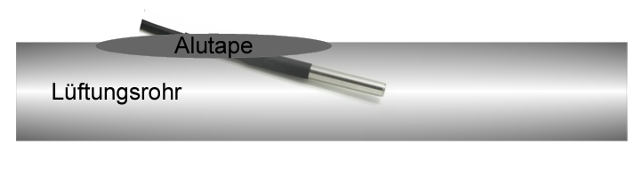

Power supply
The 12 V power supply is connected to the glider‘s electrical system. Use of a fuse for your variometer is not mandatory for gliders, but is recommended. Alternatively, the XC Vario can be connected in parallel to another device that is fused with at least 0.5 A. The wiring can be done with copper wire from 0.14 mm², we recommend 0.25 mm².

Speed to fly (S2F) switch
The vario/ pseed to fly switch can be attached to the stick or in the instrument panel. Its second pin must be connected to ground (negative pole supply). If ground contact is made at pin 4, the Vario is in set to S2F mode, if the switch is open, it is in Vario mode. The S2F display is always in operation, but the tone generator changes to S2F as input.
The S2F switch is not absolutely necessary, since it is possible to automatically switch S2F/Vario from a certain speed. This can be achieved in the Audio / AudioMode menu using the “Autospeed” setting. The “AutoSpeed” is the speed above which the variometer changes from vario to S2F mode.

RS232 port
The RS232 interface is used at pin 3 as an output (TX) on a device without Bluetooth support. This line must be connected to the input of the external device (RX). Similar to Bluetooth, the current measurement data is transmitted about 10 times a second with the serial RS232 protocol.

RS232 BT Bridge
Another possibility of the serial interface is the possibility of serial data of another device such as e.g. via pin 2 (RX). receive a FLARM and transmit it via the Bluetooth interface. This is done via the setting in Setup under System / RS232 Serial Interface / Serial BT Bridge [Enable]. The default is Disable. The feature is new and could not yet be tested in flight, but will be done soon.

Technical specifications

Power supply | 5-28V DC
Recommended voltage | 11-14 V DC
Typical power consumption at 12V | 50 mA
Variometer range | +- 1m/s bis +-30m/s
Baro and TE presuresensor ressolution | 0,01 hPa ( 0,1 m)
Baro Sensor relative precision | 0,12 hPa ( 1 m)
Baro Sensor absolute precision | 1 hPa ( 8 m )
Baro Sensor range | 0-9.000 m calibrated  til 16.000 m un-calibrated
Differential Sensor precision at 100 km/h | 1 km/h
Differential Sensor range | 10 – 280 km/h
Temperature sensor range | -10..85 °C
Temperature sensor precision | <0.5 °C
Dimensions of the case (width x height x depth) | 64x68x35 mm
Instrument pannel cut-out | 57mm
Electrical connection | RJ45 socket 8 poles
Audio out | 3.5 mm jack with switch
Airhose connections | 6 mm brass nipples 3x
Weight | approx. 300g

Maintenance
The variometer does not require any further maintenance, since a regular leak test of the instrumentation is normally required as part of the aircraft's maintenance program (AMP). This covers the testing of the variometer. Of course, a test is carried out in the factory, but this does not include the instrument hoses on the aircraft, their aging and the aging of the O-rings in the variometer itself. If the leak test is missing in the maintenance program, a corresponding addition should be made.

Warranty
For the Vario, bluevario provides a two-year guarantee from the date of purchase regarding the effort and material costs of the repair. Within this period, components that fail under normal operating conditions will be repaired or replaced free of charge, provided the device has been sent to the manufacturer free of charge.
The warranty does not cover damage caused by incorrect operation, misuse, accidents, unauthorized changes or repairs or lack of maintenance.

Limitation of liability
With the purchase of this device, the customer agrees that no liability is accepted for any direct or indirect damage, claims for damages or consequential damage of any kind and for whatever legal reason, which arise from the use of the device.
The device is a purely cross country flight tactical device, so it is not part of the mandatory instrumentation for gliders and, in case of doubt, it should not be taken as the primary source for controlling the aircraft, especially in critical flight phases. The mandatory instrumentation must be used for this. This device therefore does not require FAA or EASA approval.

